第三方采集软件系统标准化
拟制
姓名 | 签名 | 日期
黄建强
评审：
姓名 | 签名 | 日期
林振国
叶永权
邹坤
黄麦多
黄儒平
批准：
姓名 | 签名 | 日期
林振国

更改记录
版本 | 状态 | 日期 | 姓名/部门 | 更改内容
V1.0

第三方采集软件系统标准化目录
一、采集软件标准界面 1
二、软件采集机制 2
三、数据报告格式 2
3.1、标准数据报告格式 2
3.2、Sample 5
3.3、数据报告文件命名格式 6
四、应用配置流程 6

一、采集软件标准界面
1、涉及标准模板采集软件存放路径：
Perforce:HVACICT
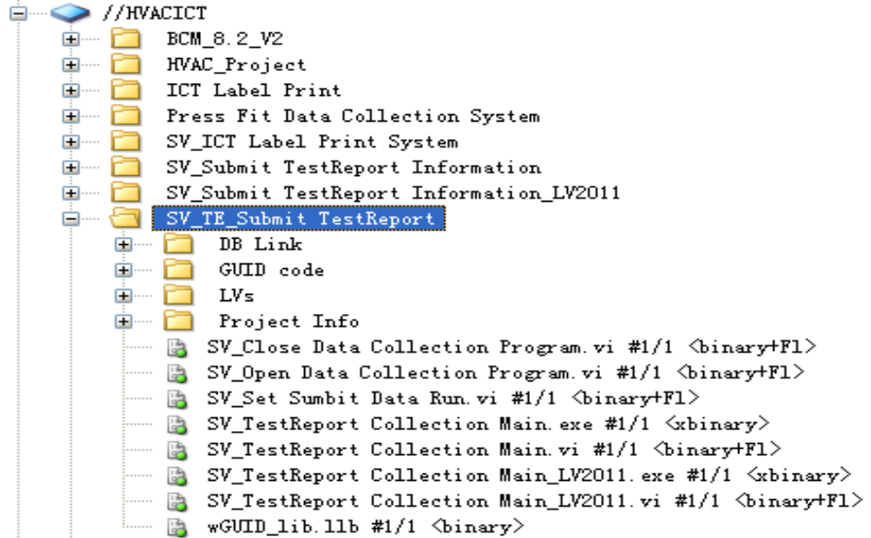

2、Labview 7.1 执行程序名称：SV_TestReport Collection Main.exe
采集软件标准界面：
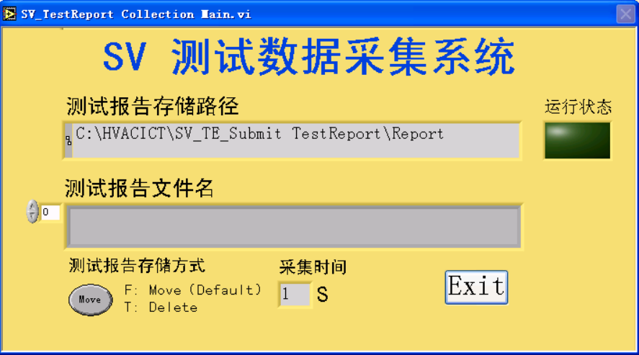
3、Labview 2011 执行程序名称：SV_TestReport Collection Main_LV2011.exe
采集软件标准界面：
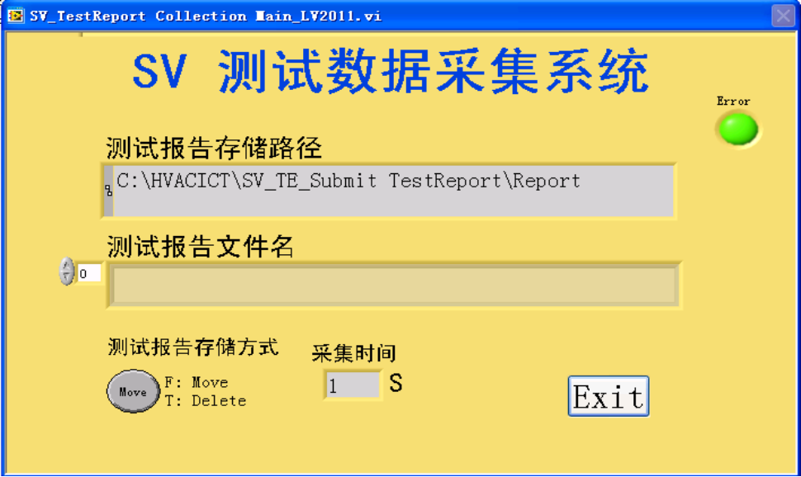

二、软件采集机制
设备系统生成标准报告格式的文本记录，利用Labview软件平台开发标准格式文本的采集软件，把文本记录进行解析，并上传至指定的数据库表格中。
默认Desay SV数据库HZHE015A，涉及数据库的表格：
UUT_RESULT 、STEP_RESULT 、STEP_PASSFAIL、STEP_STRINGVALUE、MEAS_NUMERICLIMIT 、
MEAS_NUMERICLIMIT

三、数据报告格式

3.1、标准数据报告格式
数据报告文件内容包括“EV_MSTR Data”和“ME_MSTR Data”，各参数通过“|”分隔。
“EV_MSTR Data”各参数定义如下表1：
Fieldname | Type | Sample Data | PDB Field | PDB Field Alias | Remarks
ev01 | int, | 1 | Run_Key | UUT_Order | UUT Step Number
ev02 | varchar(2), | EV | Source Mark | UUT_SOURCE | The Value is EV
ev03 | varchar(20), | 907025501471 | Product ID | DeviceA2C | Identification of the product  Default of 12 Byte DeviceA2C
ev04 | varchar(20), | EOL | Equipment Function | Equipment Function | Station Type
ev05 | varchar(40), | 9070255014711234567 | SericalNumber | Serial Number | Product Of SericalNumber,  Default Of 19 Byte Barcode
ev06 | varchar(20), | VXI75030 | Station name | Station Name | Station ID Or Computer Name
ev07 | varchar(10), |  | WPT |  | no filling in this field
ev08 | varchar(10), |  | CC |  | no filling in this field
ev09 | varchar(2), |  | WPN |  | no filling in this field
ev10 | varchar(20), | 160228142021 | Event_Date_Time | Product Time | Start TestTime Of Product.  The value is yymmddHHMMSS
ev11 | varchar(60), | EOL Test Software.Vi | Test Program Name | TestStand Name | Test Program Or Software Name
ev12 | varchar(60), | 10S01500 | User_Login Name | Login Name | User_Login Name Or Operator Name
ev13 | decimal |  | Execution_Time | Execution Time | Number of seconds the UUT test took to execute.
ev14 | Int, | -1 | Test_Socket | TestScoket | The value is value -1
ev15 | int, | 9070255014711234568 | BatchSerialNumber | BatchSerialNumber | Can use to bundle other information, if unbundling, no filling in this field. And if bundle multiple more information, the separator “_“ will be filled between each information.
ev16 | int, |  | Error Code | Error Code | no filling in this field
ev17 | varchar(10), |  | Error_Message | Error Message | no filling in this field
ev18 | varchar(2), |  | Process_Key |  | no filling in this field
ev19 | varchar(40), |  | PRE_SERIAL |  | no filling in this field
ev20 | varchar(10), |  | Defines then process type |  | no filling in this field
ev21 | int, |  | Call special defined function |  | no filling in this field
ev22 | varchar(12), |  | Duration of event in seconds |  | no filling in this field
ev23 | varchar(20), |  | Dummy |  | no filling in this field
ev24 | varchar(20), |  | Dummy |  | no filling in this field
ev25 | varchar(20), |  | Dummy |  | no filling in this field
ev26 | int, |  | Result of repairaction |  | no filling in this field
ev27 | int, |  | Count of repaired boards |  | no filling in this field
ev28 | varchar(20), |  | Dummy |  | no filling in this field
ev29 | varchar(20), |  | Dummy |  | no filling in this field
ev30 | varchar(20), |  | Dummy |  | no filling in this field
ev31 | varchar(10), |  | TestStatus | TestStatus | Status of the UUT test.
表1 EV_MSTR Data格式

“ME_MSTR Data”各参数定义如下表2：
FieldName | Type | Sample Data | PDB Filed | PDB Field Alias | Remarks
Me01 | int, | 1 | Step_Order | Step_Order | Test Or Run Step Number
Me02 | varchar(2), | ME | Source | Step_Source | Row identifier,the value is ME
Me03 | varchar(20), |  | Event_Date_Time | ProductionTime | Production time: Time of Start Test
Me04 | bigint, |  | Error_Code | ErrorCode | Error code, if the UUT test status is Error. If no error, the value is 0
Me05 | Varchar(60), |  | Error Message | ErrorMessage | Error message, if the UUT test status is Error. If no error, the value is NULL
Me06 | decimal |  | Total_Time | TotalTime | Number of seconds the step took to execute
Me07 | varchar(60), |  | Test Step_Name | StepName | Name of the step.
Me08 | Varchar(10), |  | Test Status | Step_Status | Status of the step. The value is “Passed”, “Failed”, “Error” or “Terminated” and so on.  - If Error(Me04) occur, the value is “Error”;  - If Step_Type is PassFailTest, the value is the same to Step_PassFail(Me14);  - If Step_Type is NumericLimitTest, the value depends on the relationship between Comp (Me18), Step_Data(Me19), Limit.Low(Me20) and Limit.High(Me21).  - If Step_Type is StringValueTest, the value is “Passed” when Result_String(Me22) is equal to Limits_String(Me23). And also depends on Comp(Me18).  - If other condition, and so on.
Me09 | Varchar(250) |  | Report Text | ReportText | Information Remark for this step
Me10 | Int, |  | Num_Loops | Num_Loops | The value is 1(无需关注)
Me11 | Int, |  | Num_Passed | Num_Passed | The value is 1(无需关注)
Me12 | Int, |  | Num_Failed | Num_Failed | The value is 0(无需关注)
Me13 | Varchar(10), |  | Step_Group | StepGroup | The value is "Main".(无需关注)
Me14 | Varchar(50), |  | Step_Type | StepType | Name of the step type. the value is “PassFailTest”, “NumericLimitTest”, “StringValueTest”
Me15 | Varchar(10), |  | Step_PassFail | Step_PassFail | Specifies whether the step “Passed” or “Failed”, Just for PassFailTest. If others, the value is NULL
Me16 | Varchar(50), |  | Multiple_SubName | Multiple_SubName | no filling in this field
Me17 | Varchar(10), |  | Units | Units | A label that describes the units for the measurement.  Just for NumericLimitTest, If others, the value is NULL
Me18 | Varchar(50), |  | Comp | Comp | 1、if step_type is PassFailTest, the value is NULL  2、if step_Type is NumericLimitTest, The comparison operator for the step.the value is “==”, ”!=”, ”>”, ”<”, “>=”, “<=”, “> <”, “>= <=”, “>= <”, “> <=”, “< >”, “<= >=”, “<= >” or “< >=”.  3、if step_Type is StringValueTest, the value is “Case Sensitive”, “Ignore Case”
Me19 | decimal |  | Step_Data | Limit.Step_Data | The value of the numeric  measurement that the module returned.  Just for NumericLimitTest, If others, the value is 0
Me20 | decimal |  | Limit.Low | Limit.Low | The low limit for the step comparison.  Just for NumericLimitTest, If others, the value is 0
Me21 | decimal, |  | Limit.High | Limit.High | The high limit for the step comparison.  Just for NumericLimitTest, If others the value is 0
Me22 | Varchar(50), |  | Result_String | Result_String | The response, if one exists. Just for StringValueTest, If others the value is NULL
Me23 | Varchar(10), |  | Limits_String | Limits_String | The string against which Executer compares the string returned by the module. Just for StringValueTest, If others the value is NULL
表2 ME_MSTR Data格式

3.2、Sample
EV_MSTR Data：
UUT_Order|UUT_SOURCE|DeviceA2C|EquipmentFunction|SerialNumber|StationName||||ProductTime|TestStandName|LoginName|ExecutionTime|TestScoket|BatchSerialNumber|Error Code|Error Message||||||||||||||TestStatus|
1|EV|901072500575|FA72_ATE|9010725005750000454|FA72_ATE||||150807110934|Torque_Monitor_System.exe|operator|19.00|0||0|||||||||||||||Failed|
ME_MSTR Data：
Step_Order|Step_Source|ProductionTime|ErrorCode|ErrorMessage|TotalTime|StepName|Step_Status|ReportText|Num_Loops|Num_Passed|Num_Failed|StepGroup|StepType|Step_PassFail|Multiple_SubName|Units|Comp|Limit.Step_Data|Limit.Low|Limit.High|Result_String|Limits_String|
1|ME|150807110934|0||14.00|Torque1|Failed||1|1|0|Main|NumericLimitTest|||kg-cm|>= <=|1.04|2.00|4.00|||
2|ME|150807110934|0||14.00|Angle1|Failed||1|1|0|Main|NumericLimitTest|||Degree|>= <=|3525.44|1000|3000|||

3.3、数据报告文件命名格式
数据报告文件命名格式参照如下：
DeviceA2C（12Byte）+ ”_” + SN+ “_” + YYmmddHHMMSS + “_” + Test Stutas(Passed/Failed/Terminated/Error) + “.txt”

Eg:
Filename:
901072500575_72500575000454_150807110934_Passed.txt

四、应用配置流程
4.1、软件启动设置
在电脑程序的启动文件夹中加入需要启动的exe程序，电脑开机启动会默认启动采集软件。

4.2、软件配置文件信息设置
软件涉及以下文件信息配置，文件存放路径：
C：\HVACICT\SV_TE_Submit TestReport\Project Info
A、Report Path.ini文件配置
[Station_ID]
Report Path=C:\\StepResult --采集报告文件路径；
Target Report Path=C:\\HVACICT\\SV_Submit TestReport Information\\Target Report
--备份报告文件路径；
Station_ID=Defalut --目前只能配置6个工位名称：cc、ict、eps_dispensing、aoi、coating、Default ；默认状态是Default；
TestReport_ScanTime=1 --报告采集时间间隔,单位是秒；
B、UDL.ini 文件配置
[301422]--12Byte DeviceA2C
Model Name=BM3014/22 --机型名称
Database UDL=TKP_EPS_ECU.UDL --指定数据库文件
ModelType=1 --1代表主板，0代表副板，这个配置只对TKP的coating位会有影响，其他是没有关系

配置注意事项：
- 目前生成的报告名：DeviceA2C统一采用12位条码，不符合12位条码的报告，程序
会进行采集；
- 默认处理通用的12位DeviceA2C，兼容所有业务线，要求供应商生成的文本统一采用12位DeviceA2C；

C、数据库链接UDL建立
UDL存放路径：C:\HVACICT\SV_TE_Submit TestReport\DB Link

